LinkedIn Company Page Optimisation – Defenssive

The goal of this optimisation is to make the Defenssive LinkedIn Company Page clear, credible and useful for the people you want to reach. Once approved, BizzBee will update the page directly. Alternatively, you can apply the changes yourself.
Your Company Page is often the second place a prospect looks, right after Camila's profile. When someone gets a message from her, clicks on Defenssive and lands on your page, it should tell them in a few seconds who you are, what you do for a company like theirs, and why they can trust you. Like a personal profile, a Company Page is never really about the company. It's about your target audience. So we focus on THE VALUE Defenssive can bring to YOUR TARGET AUDIENCE and THE PROBLEM YOU CAN SOLVE for them.
All our suggestions are based on the ICP research, the approved outreach messages, the choices Leo approved for Camila's profile, and the current page as of October 2026. Where something on the page couldn't be confirmed from those sources, we flag it for you to check rather than guess.

LinkedIn Hotspots

Logo
Your logo is the first thing people see when they come across Defenssive on LinkedIn: in search results, next to every post, and in the Experience section of everyone who works with you. It should be your company logo, the same one you use everywhere else, and easy to recognise at a small size.

Current & Suggestions:
✔ Your logo is on point. Great job!
The owl and shield logo is clean, it reads well even at a small size, and it uses the same blue as your banner, so the page looks consistent. A shield fits a security company well. No changes needed here.

Background photo (cover image)
Your cover image is the second visual element at the top of your page and the largest one. It grabs attention, sets the context, and shows a little more about what you do. More than anything, the right cover image helps your page stand out, engage attention, and stay memorable.

Current:
! Your cover image could use some updates
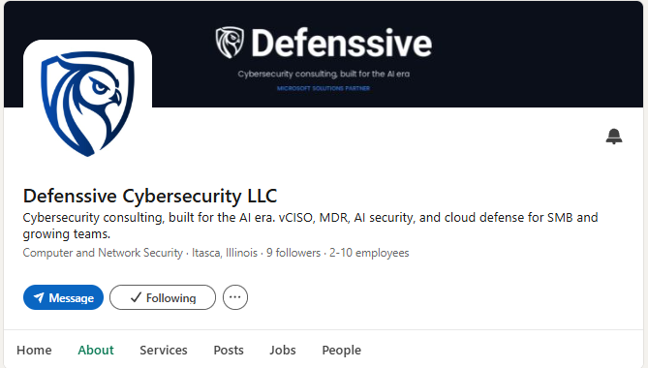
You already have a branded cover image with your logo, the line "Cybersecurity consulting, built for the AI era" and the Microsoft Solutions Partner mention, which is a good start. The dark background works well with the logo.
What we would improve is the message. The tagline and the partner line are quite small, so they're hard to read, especially on a phone. The message also talks about Defenssive rather than about the visitor, and it doesn't mention Microsoft 365, which is the main thing you do and the focus of the campaign.

Suggestions:
We'd keep the logo, the colours and the Microsoft Solutions Partner mention, and give the cover a short, larger message that speaks to the visitor. You've got two options:
Option 1: For consistency, use the same message as Camila's cover image, which Leo has already approved: "How secure is your Microsoft 365? / See your security gaps in minutes". A prospect who moves from her profile to your page will see the same message in both places.
Option 2: Use a different message on the Company Page. Here are some ideas:
Design 1: Microsoft 365 security for growing businesses / Microsoft Solutions Partner
Design 2: Find your Microsoft 365 security gaps in minutes / Try AI Security Manager free for 30 days
Design 3: Security built for the AI era / Microsoft 365 · Entra ID · Azure
Once you pick a direction, we'll prepare the design in Defenssive's colours, at the size LinkedIn recommends for Company Page covers (1128 × 191 px).

Page name
Your page name is how people find you in LinkedIn search, and it appears on every post and in everyone's Experience section. It should be the name people actually use for your company.

Current & Suggestions:
! Your page name could use a small update
"Defenssive Cybersecurity LLC"
We'd suggest dropping "LLC" and using Defenssive Cybersecurity (or simply Defenssive). "LLC" takes up space without adding anything for the visitor, and it's the same change Leo approved for Camila's headline. Keeping "Cybersecurity" in the name also tells people what you do straight from the search results.

Tagline
The tagline sits right under your page name and appears wherever your page shows up on LinkedIn. It should be short and clear, say what you do and for whom, and make a strong first impression. LinkedIn allows up to 120 characters.

Current:
! Your tagline could use some updates
"Cybersecurity consulting, built for the AI era. vCISO, MDR, AI security, and cloud defense for SMB and growing teams."
Your tagline is accurate and tells people who you work with. Two things hold it back. First, it doesn't mention Microsoft 365, Entra ID or Azure, which is what makes Defenssive different from a general security consultancy, and what people search for when they need help. Second, it relies on acronyms (vCISO, MDR, SMB). An IT manager will know them, but an owner, COO or managing partner, who is also part of the campaign, may not.

Suggestions:
Here are a few options, all under 120 characters. You can pick the one you like most and tweak it if needed.
- Microsoft security made simple for growing businesses | AI Security Manager and hands-on engineering
- Microsoft 365, Entra ID and Azure security for small and mid-sized businesses | Microsoft Solutions Partner
- Find and fix your Microsoft 365 security gaps | Try AI Security Manager free for 30 days
- Cybersecurity built for the AI era | Microsoft 365 and Azure security for growing businesses
The first one matches the line Leo approved for Camila's headline ("M365 Security made simple"), so both pages would carry the same message.

Overview / About
Your overview is your chance to tell visitors everything they need to know about your company. It should tell your company story and help people see the value of your service. Our goal is to make your overview engaging and valuable at the same time, so we follow the structure: hook, story, offer, CTA. LinkedIn allows up to 2,000 characters, but only the first two or three lines show before "see more", so those lines need to do the heavy lifting.

Current:
! Your overview could use some updates
Your overview is well organised, and the list of services with arrows is easy to scan. Mentioning the certifications and the Microsoft Solutions Partner status is a strong move, since Defenssive doesn't have client case studies yet. Here's what we'd change:
- The opening is about Defenssive, not the reader. The first lines visitors see are "Defenssive is a modern cybersecurity consulting firm helping SMB and growth-stage companies secure their stack for the AI era." We'd open with the visitor's problem instead, and keep the company introduction for the second paragraph.
- AI Security Manager isn't mentioned. It's the core of the campaign, and the free 30-day trial with no credit card is your strongest offer. Right now, a prospect who gets a message from Camila about AI Security Manager won't find it on your page.
- The industries don't match the campaign. The overview says you work with "SaaS, FinTech, healthcare". The campaign targets law firms, construction companies and manufacturers, and finance and healthcare are excluded for now because you don't have a SOC 2 report yet. A managing partner at a law firm reading this may think Defenssive isn't for them. We'd talk about small and mid-sized businesses in general instead of naming industries.
- "The full Microsoft cybersecurity certification stack" is a strong claim, and a technical reader may challenge it. We'd use the same wording Leo approved for Camila's profile: "five Microsoft security certifications", followed by the list.
- A few claims we couldn't confirm from the research: "24/7 SOC", "follow-the-sun coverage" and "global delivery". For a team of 2–10 people, prospects will likely ask how this works. If it's delivered with a partner, that's fine, but please confirm it so we can describe it accurately. Until then, we've left these out of the suggested text below.
- There's no clear call to action. "Talk to us" with a link is fine, but the free trial gives people a much easier first step.
One more thing to align: the onboarding form says the founder has 8 years of experience, while the website mentions practitioners with 10+ years. We've used 8 years below, as in the outreach messages, but please let us know if you'd prefer a different figure. Both should say the same thing, since prospects will check.

Suggestion:
Responsible for keeping your company's Microsoft 365 secure, without a security team behind you? It can be hard to know where your biggest risks are. Many attacks on smaller businesses start with a stolen password, missing MFA or a taken-over mailbox, and those settings sit in Microsoft 365 and Entra ID.
Defenssive helps small and mid-sized businesses find and fix those gaps. We focus on Microsoft security: Microsoft 365, Entra ID and Azure. We're a Microsoft Solutions Partner, our team holds five Microsoft security certifications (SC-100, SC-200, SC-300, SC-401 and AZ-500), and our founder spent eight years as a cybersecurity engineer before starting the company.
How we help:
→ AI Security Manager: connect your Microsoft 365 and Entra ID, and within minutes see your security issues and misconfigurations, with a dashboard and an executive report written in plain language.
→ Engineering: our team fixes what the assessment finds, so you're not left with a list and nobody to act on it.
→ vCISO and security advisory: security strategy, plus SOC 2 and HIPAA readiness.
→ Cloud and AI security: Zero Trust across AWS, Azure and GCP, and security for teams building AI features.
→ Managed detection and response, security engineering and SIEM tuning.
You get real security expertise without paying for a full-time security engineer or a large consulting firm.
Try AI Security Manager free for 30 days, no credit card required. Send us a message here on LinkedIn or visit https://defenssive.com/contact.
Based in Itasca, Illinois, in the Chicago area.
Note: this text uses the same opening as the About section Leo approved for Camila, so the two pages tell one story. It keeps all the services currently listed, but leads with Microsoft 365 and AI Security Manager. If you confirm the 24/7 coverage, we can add it back to the last service line.

Page details
The details in your About section help LinkedIn show your page in the right searches, and help visitors quickly check that you're a real, established business.

Current & Suggestions:
! Your page details are mostly on point, with one gap
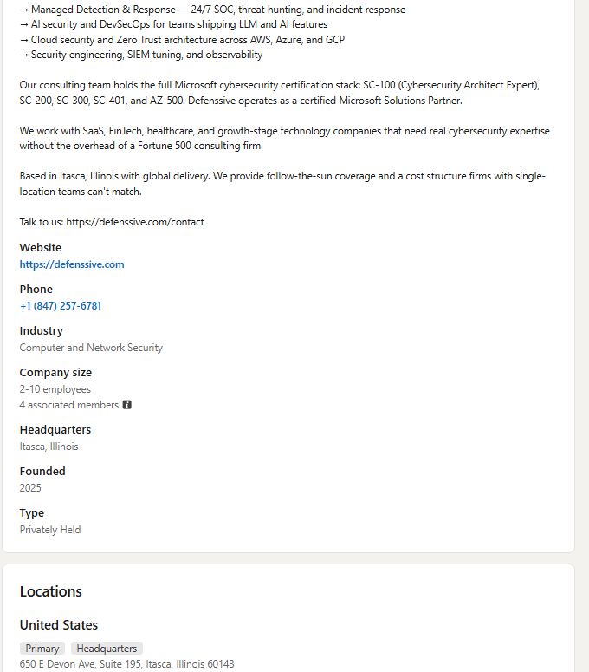
- Website (defenssive.com): ✔ Good. One note from the ICP research: when we checked on 25 September 2026, AI Security Manager wasn't shown on the website. Since the campaign sends people to the free trial, we'd recommend adding a product page and then pointing the page's button to it (see Custom Button below).
- Phone: ✔ Good. A local US number adds trust.
- Industry (Computer and Network Security): ✔ Good.
- Company size (2–10 employees, 4 associated members): ✔ Accurate. See "Linking the team to the page" below.
- Headquarters and Locations (Itasca, Illinois, with the full address): ✔ Good. A real Chicago-area address helps US prospects trust you.
- Founded (2025) and Type (Privately Held): ✔ Good.
- Specialties: ✖ Missing. See the next section.

Specialties
Specialties are keywords that describe what your company does. They help your page show up when people search LinkedIn for those terms. You can add up to 20.

Current & Suggestions:
✖ You haven't added any specialties yet
Here's the list we suggest, based on what you do and what your prospects search for. Microsoft 365 comes first, since it's your main focus:
Microsoft 365 Security | Entra ID | Microsoft Azure | Microsoft Security | Cybersecurity | Cloud Security | Identity and Access Management | Security Assessments | Security Configuration | AI Security | vCISO | Managed Detection and Response | Zero Trust | DevSecOps | SIEM | Security Engineering | SOC 2 Readiness | HIPAA Security | Microsoft Solutions Partner | Small Business Cybersecurity

Services page
The Services tab works like a small storefront on your page. It shows the services you offer, lets visitors send a request for services, and shows up when people search LinkedIn for those services.

Current:
! Your Services page could use some updates
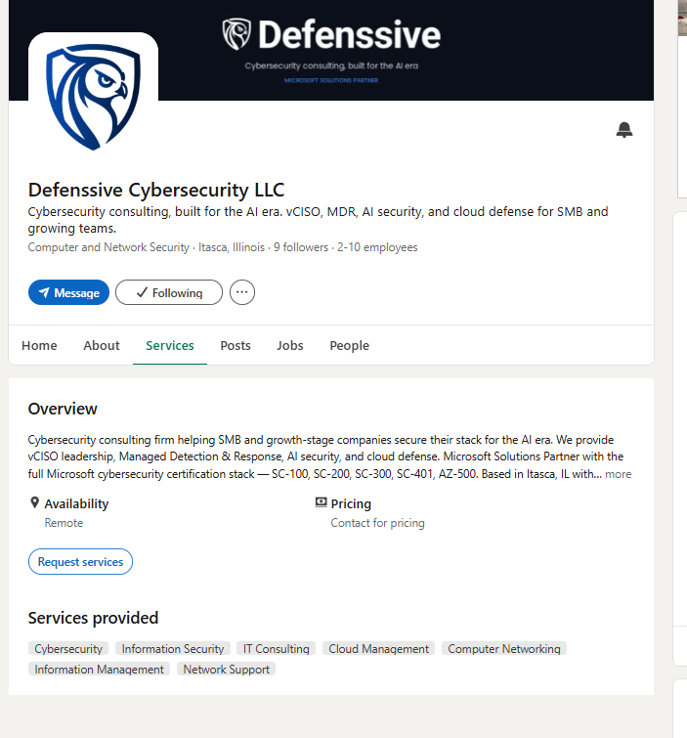
It's great that the Services tab is set up, with Remote availability and a "Request services" button, so visitors have a direct way to reach you. Three things to improve:
- The service overview repeats the start of the About section and gets cut off after two lines. A shorter version written for this tab would read better.
- Some of the services listed don't match what you do. Computer Networking, Network Support and Information Management make Defenssive look like a general IT provider, which is the opposite of your Microsoft security focus. Unless you actually offer them, we'd remove them.
- The pricing says "Contact for pricing". That's fine for the paid work, but the overview is the place to mention that AI Security Manager has a free 30-day trial.

Suggestions:
Services: keep Cybersecurity, Information Security, IT Consulting and Cloud Management. LinkedIn's services are predefined, so you can only choose from its list. When editing, search the list for options closer to your work, such as Security Consulting or Cloud Security, and add them if they're available.
Service overview:
We help small and mid-sized businesses secure Microsoft 365, Entra ID and Azure. Our AI Security Manager shows your security issues and misconfigurations within minutes, in plain language, and our engineers fix what it finds. We also offer vCISO advisory, cloud and AI security, and managed detection and response. Microsoft Solutions Partner. Try AI Security Manager free for 30 days, no credit card required.

Custom Button
Company Pages can show a custom button next to "Follow", which takes visitors straight to a link of your choice. Unlike on personal profiles, this is free for Company Pages. The options are Visit website, Contact us, Learn more, Register and Sign up.

Current & Suggestions:
! Your page doesn't have a custom button yet
Your page currently shows the "Message" button, which is good, since it lets prospects write to you directly. We'd also add a custom button:
- Once AI Security Manager has its own page on defenssive.com, use "Sign up" and link it to the free trial. This matches the main offer of the campaign.
- Until then, use "Contact us" and link it to https://defenssive.com/contact.

Other suggestions

Posts
Having an active Company Page boosts your credibility immensely. Posting from your page builds trust with your network, shows what you know, and keeps Defenssive in front of the people you want to work with. When someone checks your page after getting a message, recent posts show that the company is real and active.

Current & Suggestions:
✖ There are no posts on your page yet
At the moment, the page has no posts and 9 followers. Since Defenssive is new and doesn't have case studies yet, an empty page is the biggest gap we found. A prospect who clicks through from Camila's message has nothing to look at except the About section.
We'd recommend posting once or twice a week while the campaign runs. Posts don't need to be long. A short, useful tip with an image works well. Camila and Leo can then share the posts from their own profiles, which gives them much more reach than the page alone. Here are some topics to start with:
- Introducing Defenssive: who we are, what we focus on, and what our five Microsoft security certifications actually mean for a client
- Introducing AI Security Manager: what it checks, what the report looks like, and what access it needs when you connect it
- The Microsoft 365 and Entra ID settings most often left on their defaults
- The questions every business owner should ask their IT provider about Microsoft 365 security
- What a business email compromise looks like from the inside, and what to do in the first hour
- What to fix first when you have ten findings and one afternoon
- Microsoft's mandatory MFA for admin accounts: what changed and what to check
- Who can see your files? What to check in SharePoint before switching on Copilot
- New security features in Microsoft 365, and new security tools worth knowing about
- Microsoft zero-day vulnerabilities: what they mean for a small business and what to do
- Defenssive showcase stories, once the first free-trial users agree to share their results
Most of these topics come from the list Leo approved for Camila's profile. The post about what access AI Security Manager needs is worth doing early: the ICP research shows that law firms in particular must vet their vendors, so this question will come up.
Growing your followers: Page admins can invite their LinkedIn connections to follow the page, using a monthly allowance of invitations. We'd recommend Leo, Camila and the rest of the team invite their relevant connections, so the first posts reach more people.

Linking the team to the page
When your team members select the Company Page in the Experience section of their profiles, your logo appears next to their role, their profiles are listed under the People tab, and the page gains credibility.

Current & Suggestions:
! Make sure the whole team is linked
Your page shows 4 associated members. Please make sure that Leo, Camila and everyone else at Defenssive have selected the page (not just typed the company name) in the Experience section of their profiles, so the logo shows up next to their role. This is especially important for Camila, since her profile sends the campaign messages and prospects will click from her profile to your page.
It's also worth checking that the Defenssive role sits at the top of each person's Experience section.

Jobs
LinkedIn's Jobs tab on your page lets people explore your open positions and set up job alerts.

Current & Suggestions:
You don't have any job openings listed, which is fine. Whenever you have one, post it on LinkedIn and select Defenssive as the company, so the listing appears on your Jobs tab.

Edit Your Custom URL
A clean page URL is easier to remember, share and add to an email signature.

Current:
✔ Your page URL is customised and on point. Great job!
linkedin.com/company/defenssive is short, clean and easy to share.

Visibility
Your Company Page should be visible to everyone, including people who aren't signed in to LinkedIn, so it can also show up in Google search results.

Current:
✔ Your page visibility is on point. Great job!

Points to confirm before we update the page
To keep everything on the page accurate, please confirm these points:
- Is the 24/7 SOC and follow-the-sun coverage delivered by your own team or with a partner? We'll describe it accordingly, or leave it out.
- Which figure should we use for the founder's experience: 8 years (onboarding form) or 10+ years (website)?
- When will the AI Security Manager page be live on defenssive.com? We'll point the custom button to it once it is.
- Which cover image do you prefer: Option 1 (same as Camila's) or one of the Option 2 designs?

